Gretchen Krupp

Mezzo – Soprano

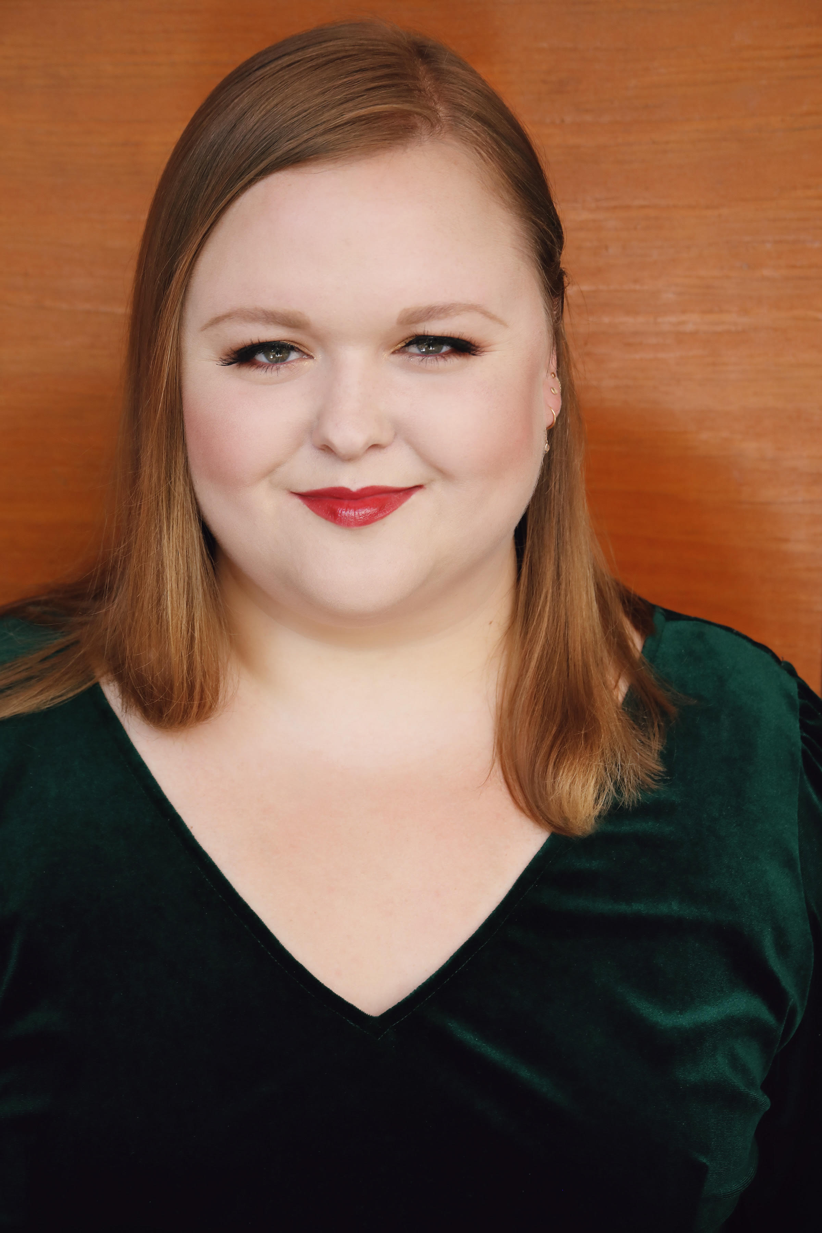Acclaimed for her "show-stopping," "ripe, round," and "searing" voice, Gretchen Krupp is rapidly establishing herself as a magnetic force in the opera world, distinguished by her extraordinary vocalism and compelling theatricality. Her diverse repertoire spans centuries and styles, from classic to contemporary, dramatic to comic.

In the 2024-2025 season, Ms. Krupp debuts with the **York Symphony Orchestra** as the mezzo soloist in Verdi's *Messa da Requiem*. She also returns to the **Santa Fe Opera** to sing Waltraute and cover Fricka in a new production of Wagner's *Die Walküre* under the baton of James Gaffigan. Future engagements include return appearances with **The Dallas Opera** as Mother Jeanne in *Dialogues des Carmélites;* performing the role of Tebaldo, and covering Eboli in *Don Carlo.*

The 2023-2024 season featured Ms. Krupp in several significant performances, beginning with **The Dallas Opera** for the premiere of Joby Talbot and Gene Scheer's *The Diving Bell and the Butterfly*. She subsequently made her **Pittsburgh Opera** debut, stepping in on short notice as Mary in *Der fliegende Holländer*. Returning to **The Dallas Opera**, she debuted as Erste Magd in *Elektra* and appeared as a featured soloist in The Hart Institute for Women Conductors Showcase Concert. Ms. Krupp concluded her season with a significant role debut as Fricka in *Die Walküre* with **The Atlanta Opera**.

In 2023, Ms. Krupp debuted with the **Santa Fe Opera** as Mary in *Der fliegende Holländer* and covered the role of Ježibaba in *Rusalka*. As a recent alumna of **The Atlanta Opera's Glynn Studio Artist Program**, she performed as Flosshilde and covered Fricka in *Das Rheingold*, covered Judith in *Bluebeard's Castle*, and portrayed Paquette in *Candide*, Kate Pinkerton in *Madama Butterfly*, and Edith in *The Pirates of Penzance*.

Her concert appearances include engagements with **The Dallas Opera** and **Baltimore Concert Opera**. In summer 2021, Ms. Krupp returned to **Wolf Trap Opera** as a Filene Artist, performing Armelinde in Viardot's *Cendrillon* and Dorothée in Bologne's *L'Amant Anonyme*. That season also featured her first performance of Wagner's *Wesendonck Lieder* in recital and an appearance as soloist with the **National Symphony Orchestra**.

Prior to the pandemic, Ms. Krupp reprised the role of Samira in Corigliano's *The Ghosts of Versailles* for her European debut at the **Château de Versailles Spectacles**. She was also awarded the prestigious Georgina Joshi International Fellowship, which supported her studies in Berlin. The 2018-2019 season included her return to **The Glimmerglass Festival**, where she debuted as Samira in *The Ghosts of Versailles* and Mrs. Noye in Britten's *Noye's Fludde*, alongside her mainstage debut with **Greensboro Opera** as the Witch in *Hansel and Gretel*.

Her notable roles include Cornelia in *Giulio Cesare*, Principessa in *Suor Angelica*, Mère Marie in *Dialogues des Carmélites*, Mistress Quickly in *Falstaff*, Chocholka/Woodpecker/Innkeeper's Wife in *The Cunning Little Vixen*, Auntie in *Peter Grimes*, Marcellina in *Le nozze di Figaro*, Alisa in *Lucia di Lammermoor*, and the Marquise in *La fille du régiment*.

Ms. Krupp was named a 2018 Grand Finalist in the **Metropolitan Opera National Council Auditions** (now the Eric and Dominique Laffont Competition) and a Finalist in the 29th Annual **Eleanor McCollum Competition for Young Singers**, culminating in the 2017 **Concert of Arias with Houston Grand Opera**. She is a proud alumna of prestigious young artist programs at the **Santa Fe Opera**, **Wolf Trap Opera**, **The Glimmerglass Festival**, **Des Moines Metro Opera**, and Dolora Zajick's **Institute for Young Dramatic Voices**.